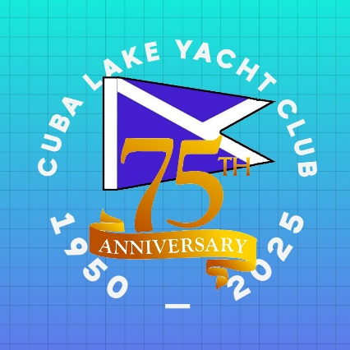
CUBA LAKE YACHT CLUB 2025 SOCIAL CALENDAR

MAY
Saturday, May 10th Club Clean-Up/Readying for the Season 9:00 AM
Monday, May 26th Chili Cook-off/Sandwich Lunch
JUNE
Saturday, June 7th Private Event
Sunday, June 15th Father’s Day Picnic
Friday, June 27th Opening Event for CLYC 75th Anniversary With
Live Music Featuring TWO GUYS DRINKING BEER
Saturday, June 28th Social Gathering
Sunday, June 29th Mini Regatta Celebrating 75 Years of Sailing
JULY
Thursday, July 3rd Annual Chicken BBQ
Saturday, July 5th Social Gathering
Saturday, July 12th CLYC Yacht Club/Cottage Owners Family Picnic
Thursday, July 17th Christmas in July Painting with Shelby
Saturday, July 19th Club Kids’ Party
Saturday, July 26th Taco Bar Party

AUGUST
Saturday, August 9th Private Event
Saturday, August 16th Bolde Mother’s MC Regatta
Saturday, August 23rd August Harvest Corn Roast
Sunday, August 31st CLYC Annual Meeting and Dinner
SEPTEMBER
September 1st Labor Day Soup Luncheon
September, 6th Lions Club Lobster/Steak Bake

