CUBA LAKE YACHT CLUB SOCIAL CALENDAR 2026

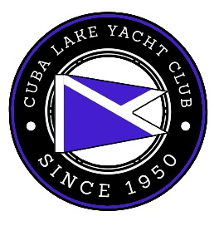

MAY
Saturday, May 17 th Club Clean-Up/Opening 9:00 AM
Monday, May 25th Memorial day Chili/Sandwich Lunch

JUNE
Friday, June 26th With Two Guys Drinking Beer

JULY
July 2nd Private Event 1-5 PM
Friday, July 3rd Annual Chicken BBQ 5:30 PM
Saturday, July 4th Champagne brunch
Saturday, July 11th Honkey Tonk Hoedown with
The Jack Ellis-Keepin It County Band Fund Raiser
Saturday, July 18 th CLYC/CLCOA Family Picnic
Saturday, July 25th Pirate Ball/Sailing School Awards
J
AUGUST
Saturday, August 1st Party
August 8th Bolde Mothers MC Scow Regatta
August 22nd Taco Dinner/Euchre Night
August 28thth Private Event

SEPTEMBER
September 4th Beer Tasting Happy Hour
September 7th Labor Day Soup Luncheon/
CLYC Annual Meeting

September 12th Lions Club Steak/Lobster Bake

OCTOBER
Club Cleanup and Closeup to be determined.

